Biography 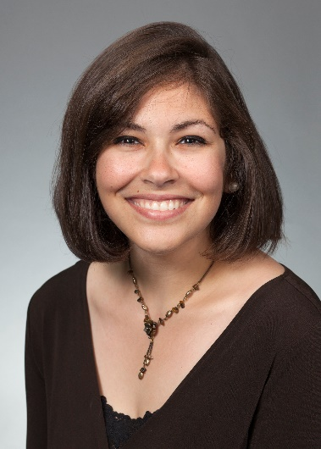
Marina Boushra is an emergency medicine and critical care physician at Cleveland Clinic Main Campus and Fairview. Her academic interests include the care of pregnant and peripartum patients, airway and ventilator management, toxicologic emergencies, and ED-ICU transitions. She is passionate about medical education and is actively involved with the emergency medicine and internal medicine residencies. She is particularly excited about the evolution of emergency medicine-trained critical care physicians and creating programs to translate best practice across the ED-ICU interface.

